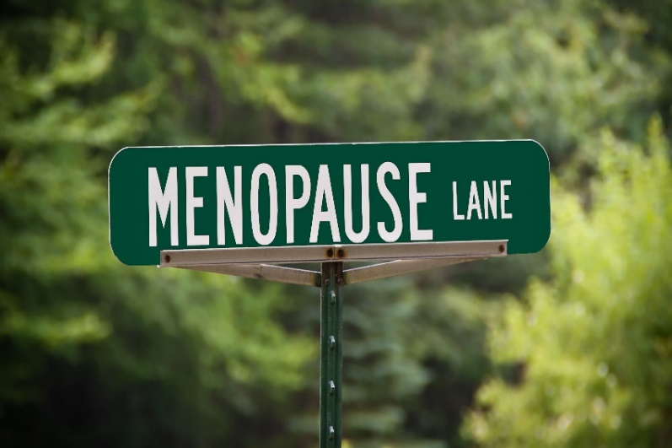
Your referral has been received by womenMD.

- The Mindfulness & Menopause - Evidence Based Program explores: Vasomotor Symptoms, Sleep Disturbances of Menopause, Mood Disorders and Menopause, Genitourinary Symptoms of Menopause, Weight Changes and Cardiovascular Disease, Lifestyle Medicine, Complementary and Alternative Medicine and Hormonal/Non-Hormonal Pharmacologic treatment of Menopause. This program is 12 hours of education and incorporates mindfulness meditation and cognitive behavioural strategies. Our registration is limited and our programs do fill up quickly, if you are interested in pursuing your referral please go ahead and sign up for the program to secure your spot.

- An email with intake forms will be sent to the email address that was provided to us on your referral form. Please set aside enough time to fill out the forms from start to finish, approximately 30-45 minutes (the forms will come back as not completed if you leave the session prior to completion, this will result in having to re-do the forms and will delay your referral process). Once completed the forms will auto populate back into your chart. (You will be prompted to enter your birthdate to open the e-forms, if you are unable to access the forms, please give our clinic a call to confirm that we have the correct date of birth on file). Please don't contact the clinic until your intake forms have been completed.

- Our current wait time for a Menopause consultation is approximately 3 months. The consultation which is included as part of your referral will be conducted by telephone by our NAMS certified physician. Please give the office a call if you register for a Menopause program as your consultation will be expediated prior to the program start date.

- If it is determined that an in-office appointment is required for a pelvic exam that appointment will be set up by our office following your consultation.

- Menopause is a complex array of symptoms and presents differently in everyone. The treatment approach to Menopause is multipronged and not fixed by any pill or hormone alone. womenMD takes a holistic to approach to symptom management, Hormone Therapy (HT) may or may not be part of your treatment plan. Bioidentical Hormones are available as government approved hormone formulations; non-approved custom compounded preparations are marketed at Bioidentical but content is uncertain. There is lack of evidence to support its safety and efficacy. Please note that womenMD does not prescribe compounded Bioidentical Hormones.

